**AARON CHANSA-04/09/2024**

**ACADEMIC AND PROFESSIONAL QUALIFICATIONS**

# Master’s Degree in Educational Management and Leadership

# Bachelor’s Degree in Public Administration and Development

# Diploma and Certificate in Teaching

# Certificate in Computer Studies

# Certificate in Monitoring and Evaluation [M & E]

# Certificate in Statistical Packaging in Social Sciences [SPSS]

**AWARDS**

**#** Honorary PhD in Educational Leadership -GEPEA University of Austria

**PROFESSIONAL EXPERIENCE**

# Extensive collaborations with UNESCO, UNICEF,GEAR Alliance, Oxfam IBIS, Ministry of Education, Teaching Council of Zambia, Teaching Service Commission, Examinations Council of Zambia and Higher Education Authority in formulating various educational policies and frameworks

# Joint advocacy actions with more than 30 Civil Society organizations

# Part -time lecturer in Educational Administration at the University of Zambia

# Taught at 3 private schools in Lusaka and Copperbelt provinces

# Leadership mentor at Zambia National Women’s Lobby

# Given speeches and panel discussions at national and international conferences

# Taught at 2 Government schools in Lusaka and Copperbelt provinces

# Prominently and consistently featured on national Television and Radio stations

**CURRENT LEADERSHIP POSITIONS**

**# Executive Director-** National Action for Quality Education in Zambia [NAQEZ]

# Board Chairperson-Green park University College

# Board Chairperson-Education Hope Foundation

# Board Vice Chairperson -Rural Focus Zambia

# Board Vice Chairperson –Chalk Breakers Zambia

#Board Chairperson-Naboye Secondary School

**PREVIOUS LEADERSHIP POSITIONS**

**# President**-University of Zambia Political and Administrative Studies Association [UNZAPASA]

#Vice -President- University of Zambia Distance Students Association [UNZADESA]

# **Deputy Director [PR]-**Professional Teachers Union of Zambia [PROTUZ]

# Board Member-Mufulira College of Education

**INTERESTS**

Reading, writing, teaching, watching football and wildlife

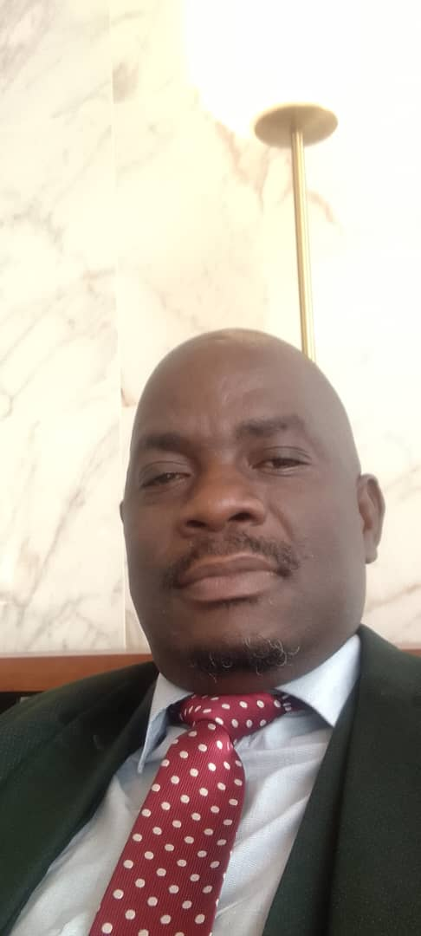 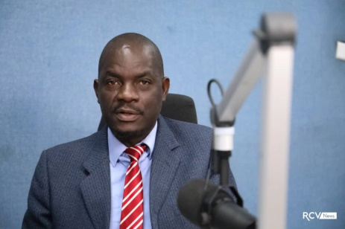 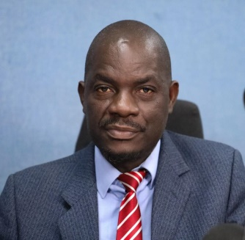

**Contacts: +260 979 552 885,aaronchansa80@gmail.com**